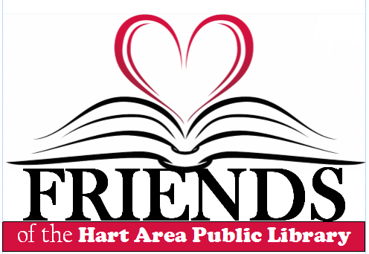
Are you a Friend of the Library?

The Friends of the Hart Area Public Library are concerned citizens who share the belief that strong public libraries are valuable community resources. Friends are advocates who enrich and promote their libraries.
The Friends of the Hart Area Public Library group is a 501(c)3 organization that exists to support programming and operations of the Library. Income from various Friends sponsored events help fund programming, and provide for an annual college scholarship.

Thank you for being a Friend!

Friends Membership Registration Form
Name__________________________________________________
Address ________________________________________________
State and Zip ____________________________________________
Phone __________________ E-Mail _____________

Hart Area Public Library
415 S. State St.
Hart, MI 49420

